**PRESS RELEASE**

**COMMUNICATIONS AND MEDIA TEAM OF THE 2023 ASEAN SUMMIT**

**No.74/SP/TKM-ASEAN2023/ENG/5/2023**

**Indonesian President to Announce the 42nd ASEAN Summit 2023 Declaration**

**West Manggarai, 11 May 2023** **–** President of the Republic of Indonesia Joko “Jokowi” Widodo will personally read the declaration or the outcome of the 42nd ASEAN Summit held in Labuan Bajo, West Manggarai, East Nusa Tenggara (9 – 11 May).

Teuku Faizasyah, Spokesperson for the Ministry of Foreign Affairs, conveyed the statement on Thursday (11 May).

“I am still waiting for the Summit’s outcome, which will be announced by Mr. President,” said Teuku Faizasyah

According to Teuku, the declaration which will be read by President Joko “Jokowi” Widodo would have been agreed upon by the ASEAN member states. The declaration may contain around 10 points which are the final results of a series of meetings conducted at the 42nd ASEAN Summit 2023.

“To my knowledge, there are 10 (points), which are usually called deliveries or leaders’ declaration,” said Teuku.

He mentioned that three potential topics may be included in the declaration. The first topic is related to trafficking-in-persons, the second topic is related to the utilization of local currencies aside from the US dollar, and the third one is the roadmap for Timor-Leste’s full ASEAN membership.

All three topics are expected to be included in the declaration because they have been of concern to the ASEAN member states in recent times.

“Those three issues may be agreed upon by the leaders through the declaration,” said Teuku.

Teuku explained that all ASEAN member states must implement the ASEAN Summit declaration despite the absence of ASEAN Leaders in the Summit. This is because ASEAN member states have agreed to implement the declaration.

ASEAN member states can carry out the follow-up on the declaration through cooperation between related government institutions. The cooperation shall be adjusted to the 42nd ASEAN Summit 2023 declaration.

“Starting cooperation in a particular sector and identifying concrete areas of cooperation,” said Teuku.

As previously reported, President Jokowi chaired five sessions on the first day of the ASEAN Summit 2023.

These sessions were the Opening and Plenary Session, ASEAN Leaders Interface with the ASEAN Inter-Parliamentary Assembly (AIPA), ASEAN Leaders Interface with ASEAN Youth Representatives, ASEAN Leaders Interface with the ASEAN Business Advisory Council (ASEAN-BAC) Representatives, and ASEAN Leaders Interface with the High-Level Task Force on ASEAN Community’s Post-2025 Vision (HLTF-ACV).

There will be two meetings chaired by President Joko Widodo on Thursday (11 May), namely the Retreat Session and the Indonesia-Malaysia-Thailand Growth Triangle (IMT-GT) Summit.

Meanwhile, the Brunei-Indonesia-Malaysia-Philippines East ASEAN Growth Area (BIMP-EAGA) Summit will be chaired by Malaysian Prime Minister Anwar Ibrahim as Malaysia currently holds the chairmanship of BIMP-EAGA. All three meetings will take place at the Meruorah Hotel, Labuan Bajo. (Tri Antoro InfoPublik/TR/Elvira/WW/PPR)

***

For more information, please contact:

**Director General of Public Information and Communications of the Ministry of Communications and Informatics – Usman Kansong (0816785320).**

Get more information at <http://asean2023.id>, <https://infopublik.id/kategori/asean-2023>, and <https://indonesia.go.id/kategori/ragam-asean-2023>

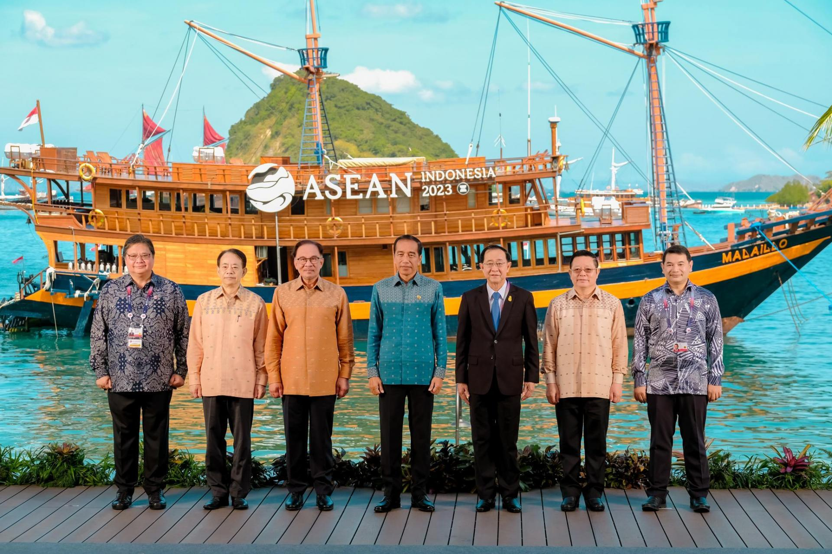

The 15th Summit of IMT-GT (Indonesia-Malaysia-Thailand Growth Triangle) family photo during the 42nd ASEAN Summit in Labuan Bajo, (11 May 2023). Photo: ASEAN2023 Host Photographer